**Business Requirements Document**

**Project: eVal Implementation**

**BRD Title: Unique Identifiers Via EDS Accounts**

**BRD: #5**

**Development required by:**

***Washington State’s eVal Team***

**BACKGROUND**

This Business Requirement Document (BRD) is part of a set of business requirement documents that are part of the Seattle School District’s 2015 implementation of Washington State’s online evaluation tool, eVal. eVal is an online tool developed by the State to support teacher professional growth in alignment with Washington State’s mandates for TPEP (Teacher Principal Evaluation Process). The project goal is to successfully integrate this tool into the District’s TPEP activities, adhering to the District’s obligations of its CBA and to the spirit of the TPEP process which is aimed at fostering professional growth through collaborative, face-to-face discussions between teacher and evaluator.

BRDs related to eVal functionality have been submitted to the State’s eVal development team. BRDs related to back-office activities which require District development have been submitted to DOTs (the District’s development team). Where noted, several of these documents require review and collaboration from both teams.

*For further information, please see Excel file “eVal Seattle - Enhancements and BRD Index” which contains listing of each enhancement that has been approved for development and the related BRD and assigned development team.*

| Version No. | Date | Name | Description of Change |
| --- | --- | --- | --- |
| 1 | 10/31/14 | Donna Schmidt | Baseline; submitted to for review to eVal, DOTs and HR teams |
| 2 | 11/19/14 | Donna Schmidt | Updated to reflect EDS/eVal/District discussion on 11/14/14 where potential solutions were discussed for linking EDS account to certificate number and flowing that value to eVal team; updated Review/Approval table to reflect current status |

# High Level Requirement Description

This set of requirements addresses the need for a dependable, consistent identifier for each District employee in eVal which the District can then use to map their record to the corresponding record in the District’s systems when data is received through the back-end.

**This BRD contains requirements that involve activities from both the eVal team and the District.**

# Business Objective

The District must be able to upload eVal data into its systems and programattically map the records to the appropriate SAP record. For this to happen consistently and accurately, the record must have an identifier that is static and assured to be the same in both systems. The District, eVal and EDS teams have agreed to use the ***certificate number*** which is available to EDS when the EDS account is linked to the user’s eCert account and which will then be passed to the eVal team so that it is included in any data provided ot the District.

# Business processes impacted by the change

***Current State:***

**General purpose of EDS account --** OSPI provides District staff single sign-on for a variety of District applications and resources through the OSPI portal. Staff access these resources by creating an EDS account. Certificated staff rely on their EDS account for certificate activities regardless of their employment with any specific District (i.e., the staff’s relationship with the EDS account corresponds to their relationship with the State; not their relationship with the District). Accounts are managed by several individuals at the District who have been delegated EDS Security Managers.

**Requesting eVal --** The eVal tool is one of the resources accessed via the OSPI portal. Therefore, in order to have eVal, a staff member must request it through their EDS account. Currently, there is no consistency in how staff create their EDS account – some request eVal, some use their District email, some enter their certificate number, but many do not. Each EDS Account request for eVal goes to a District EDS Security Manager for approval. The EDS Security Manager validates that the user is at the District, their school and their role (i.e., teacher, etc.) Note: The act of setting up an EDS account does not go to the security manager; it is only the request for eVal that can be accepted or denied by the security manager.

**Linking to certificate number --** The EDS account, ideally, is linked to the staff person’s eCert account, allowing EDS to ultimately expose the person’s certificate number to the eVal system via SAML token or nightly batch file. However, many EDS accounts are not linked. A new EDS account will only become linked if a user enters a valid certificate number at the time that they set up their account. For an existing EDS account to be linked, the user must call EDS customer support.

**Using District email as an identifier –** EDS has three places where a user can enter their email: UserName, Primary email and Alternate email. The purpose of these are to provide the user with a personal email from which they can reliably manage their EDS account regardless of employment with any particular District. Therefore, there is not currently an email field which can be reliably used to store the District email.

***Future State***

**Onboarding new eVal users who do not yet have an EDS Account.** As part of the eVal onboarding process, users will be provided instructions on how to set up their EDS account in a manner that links it to their eCert account. When the account request comes to the EDS Security Manager, the manager will check the account information against an SAP report to confirm the school, role, eVal access and certificate number have been added. If the user has not entered the necessary information, they will be asked to modify accordingly.

**Onboarding new users** **who already have an EDS account.** Linking EDS account to certificate number. Users who already have an EDS account, when that account is not already linked to a certificate number, will have additional instructions for contacting EDS customer support and requesting that their accounts be linked.

**Adding eVal to existing EDS accounts.** [As of November 20, 2014, only an EDS Security Manager can add eVal to an existing EDS account. The District is in discussions with EDS team to see if functionality can be added which would allow a user to add eVal to an existing account]

**Exposing certificate number to eVal team:** The EDS team will expose the certificate number in their SAML token and will include it in the nightly batch file supplied to the eVal team.

**Matching eVal records which do not correspond to an SAP record.** If a user in eVal does not have a matching certificate number in SAP, they will show up on the SAP upload error report. The cause for this would be an employee for whom their certificate number was incorrectly keyed into SAP.

# Requirement Details

|  |  |  |
| --- | --- | --- |
| ID | Requirement | Purpose or expected outcome |
| Req 5.1 | Certificate numbers must be correctly entered into SAP | Currently, certificate numbers are hand keyed and some are not accurately provided or entered |
| Req 5.2 | **The eVal system** will retrieve the cert# from the EDS system and use them as record attributes for each eVal user. | The District requires the ability for each HR-based employee profile that is entered into SAP to coincide with the appropriate eVal user via a single EDS login, including the linkage of employees that may work multiple locations and multiple positions to be identifiable under one unique ID.  *Expected outcome:*  The District will be able to programmatically map all eVal users to the appropriate SAP records, including instances where a single user has multiple EDS/eVal school assignments and/or multiple role types and/or where a single user has multiple EDS accounts. |
| Req 5.3 | **The District** will train all users to enter their Certificate # into the EDS field for Certificate #. | [Note:This requirement is included here for consistency only; it is a business process requirement and does not require any development] |
| Req 5.4 | **The District’s EDS Security Managers** will have a process for notifying appropriate staff when an eVal request comes to them for which the certificate number does not match the SAP value | [Note:This requirement is included here for consistency only; it is a business process requirement and does not require any development] |
| Req 5.5 | **The District’s SAP team** will provide reporting to the EDS Account Managers with all potential users, eVal roles, email and certificate number | [Note:This requirement is included here for consistency only as part of the overall EDS account management process. Details of this request are documented in a separate BRD submitted to the District’s development team] |
|  | EDS Account Report:”Existing District accounts without eVal”  **EDS team to provide** District with a report that the District Administrator can download into csv format showing all District EDS accounts that do not include eVal. The report will have no formatting and will be a straight data file with a header row and a record for each combination of EDS user name, school name and EDS role (i.e., if a user is both a teacher and a librian in EDS, they will have two records in the file). Data elements will include User Name, School, District, Certificate Number *[note: project team stil needs to identify all desired data fields for this report… Donna]* | The District needs to be able to identify which potential eVal users already have an EDS account but do not have accounts that include eVal. This report is necessary because in order to use eVal, these users will need the necessary information added to their accounts.  This data download must not have any formatting that would preclude it from being easily uploaded into the District’s systems or which would preclude a user from easily sorting, filtering and grouping the data. |
| Req 5.6 | **District’s development team** to have the ability, on request of an EDS Security Manager, to match the results of the above report to SAP data in order to generate a report showing the correct emails and certificate numbers for each record.  Timing: These requests most likely will occur a few times before each launch. Once the tool is in general use (after a staggered 3-year launch), it may no longer be needed. | Before each launch, an EDS Security Manager will need to communicate to those users who have an EDS account but do not have eVal and help prepare their accounts. |
| Req 5.7 | EDS Account Report:”Existing District accounts with eVal”  **eVal team to provide** District with a report that the a District Administrator can download into csv format showing all District EDS accounts that have eVal. The report will have no formatting and will be a straight data file with a header row and a row for each unique combination of user, EDS role, school and eval role (i.e., if a user is both a head principal and a school administrator in eVal, then they will have two rows in the file). | The District needs to be able to validate from time to time the accuracy of the information in EDS for existing eVal users to make sure that the user name remains the District email and that all certificate numbers have been entered correctly. See the item below for further details.  This report must not have any formatting that would preclude it from being easily uploaded into the District’s systems or which would preclude a user from easily sorting, filtering and grouping the data. |
| Req 5.8 | From time to time, an EDS Security Manager may request **the District development team** to match the data in the above file to SAP records in order to programmatically identify errors | Once all 3500 District users are on eVal, there is a high probability that the unique identifiers in EDS may not always be accurate (and, thereby, will no longer be useable as unique identifiers). For example, the EDS Security Manager may inadvertently approve a record that has the wrong number or that is missing a number. Or a user may inadvertently change their account information. The District needs the ability to audit this information and make necessary adjustments. Otherwise, the data that is received from the back-end may not accurately map to District data. |

**ILLUSTRATION – 5.1**

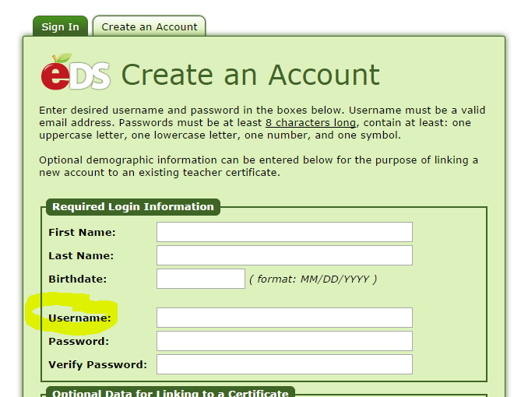

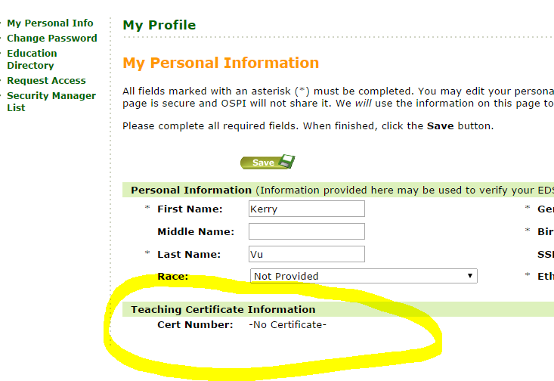

# Out-of-Scope

# Review and Approval

(Some of the processes for relying on the cert number as a unique identifier are still under discussion; however, the general concepts presented in this document have been reviewed/approved by the stakeholders below)

|  |  |  |  |  |
| --- | --- | --- | --- | --- |
| Team | Person | Organizational and Project Roles | Role | Date review/approval received |
| Project | Clover Codd | Exec Director Strategic Plan & Partnerships; **Project Sponsor** | Approve project deliverable | 11/5/14 |
| HR | Brent Jones | Asst Superintendent for Human Resources; Project Steering Committee representative for HR; Internal customer for many of the technology updates requested in these documents | Approve project deliverable | 11/19/14 |
| HR | Elaine Williams | Subject matter expert representing Labor Employee Relations Team | Review | 11/14/14 |
| HR | Denise Williams-Saunders | Subject matter expert representing Labor Employee Relations Team | Review | 11/14/14 |
| HR | Sue Means | Subject matter expert representing Labor Employee Relations Team | Review | 11/14/14 |
| DOTs | Nancy Petersen | Director, Enterprise Applications | Informational | 11/6/14 |
| DOTs | James Bradley | Manager, Business Applications | Informational | 11/6/14 |
| DOTs | Mabel Mah | Sr Business Analyst (SAP/HR); project systems analyst representing DOTs for design and development | Review and accept as milestone deliverable | 11/14/14 |
| eVal Dev Team | Anne Chinn | Lead eVal Developer | Review and accept as milestone deliverable | 11/7/14 |
| eVal Dev Team | Dana Anderson | eVal Supervisor/ Project Manager | Review and accept as milestone deliverable | 11/7/14 |